HELP US RAISE $50,000!
GRAND KREWE DE LIBERTALIA, INC.

CALENDAR CAMPAIGN FUNDRAISER

May 28, 2026

Subject: Launch of 30-Day Challenge Fundraiser

Greetings GKLIB Members,
As you are aware, we are working toward securing a new float to continue participating in Tampa Bay area parades. The estimated cost for a new float is $50,000, and to support this effort, we are excited to launch our 30-Day Calendar Challenge Fundraiser beginning Monday, June 1, 2026.

Our initial campaign goal is $25,000, and with strong participation, we can move even closer to reaching our full $50,000 target.

How It Works
This is a 30-day giving challenge where each day corresponds to a donation amount:
- Day 1 = $1
- Day 2 = $2
- …
- Day 30 = $30
Total potential raised per participant (30 days): $465 | With 20 members participating: $9,300

Campaign Structure - You can participate in any of the following ways:
- Individual Challenge: Members complete the full calendar
- Shared Sponsorship: Friends and family “claim” specific days
- Team Competition: Members compete to complete their calendars

Materials Needed - Printable or digital calendar tracker

The campaign will run from June 1 – June 30, 2026. Together, through unity and commitment, we can meet, and exceed, our fundraising goals.

Let’s come together in Krewe spirit, support one another, and make this fundraiser a tremendous success!

In Krewe Spirit,
Natalie M. Powell-Glover, Treasurer
natp1969@yahoo.com | 813.335.9070

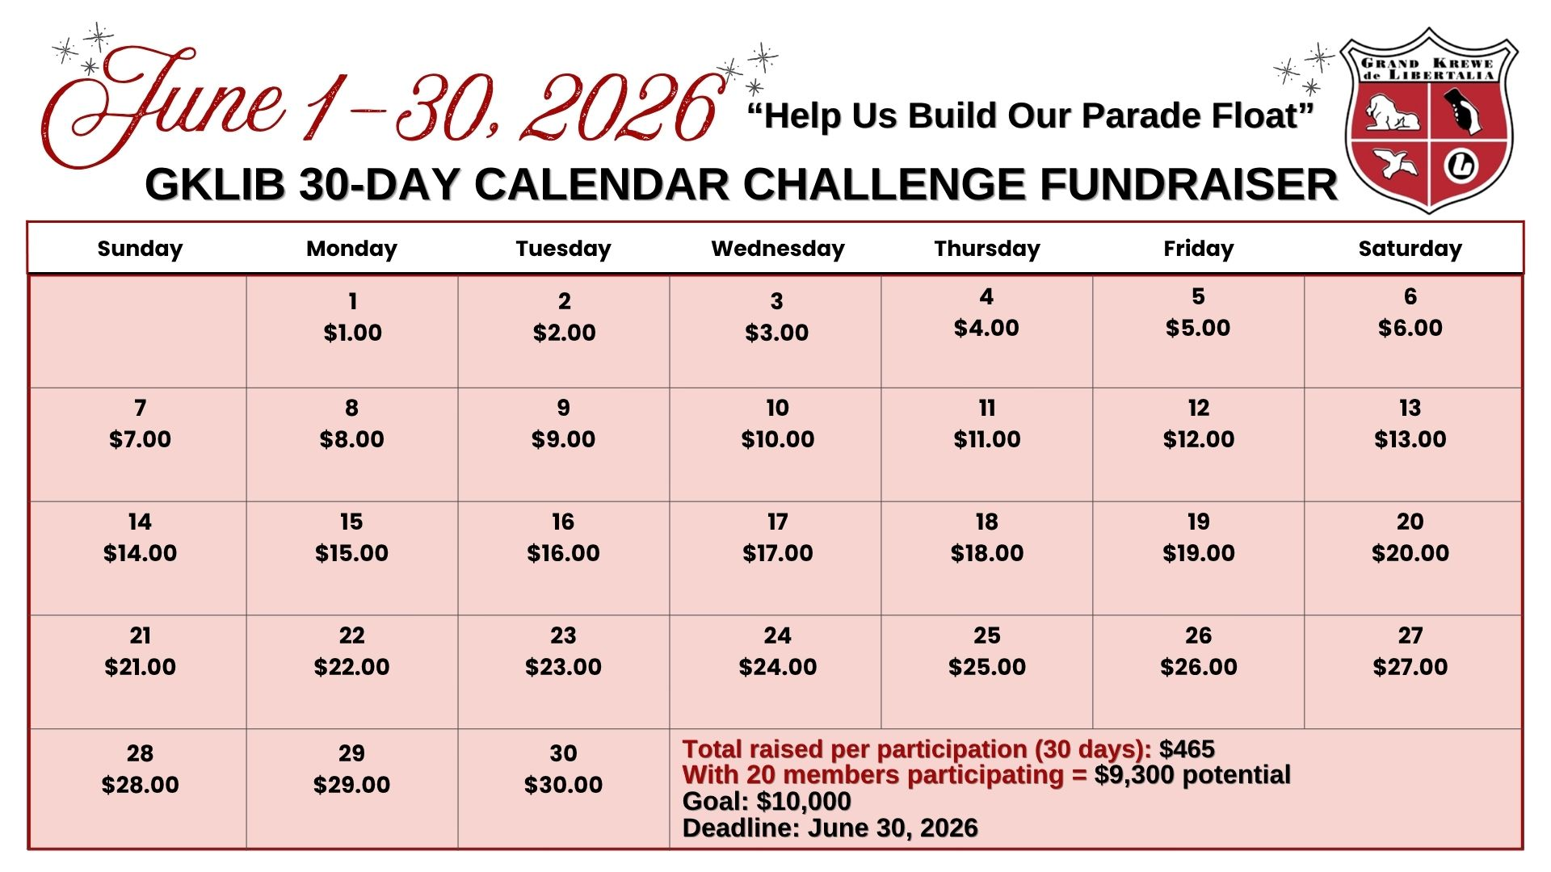
How Members Should Share
“Hi! I’m participating in a fundraiser for the GKLIB Krewe. You can support by choosing
a day (1–30) and donating that amount. Every dollar helps us build our parade float!”
QR Code to GKLIB 30-Day Calendar Challenge Fundraiser


STEP 1: Scan the QR Code shown above to access the fundraising campaign page.
STEP 2: Select one of the following options (see fundraiser examples below):
- Create a Team – Create your own fundraising team and invite family, friends, coworkers, and supporters to join your efforts.
- Join a Team – Join an existing team listed on the campaign page and contribute toward their fundraising goal.
- Fundraise Solo – Prefer to participate individually? Select the option to fundraise on your own and share your personal fundraising page with others for support.

Choose the option that works best for you and begin supporting our campaign today!
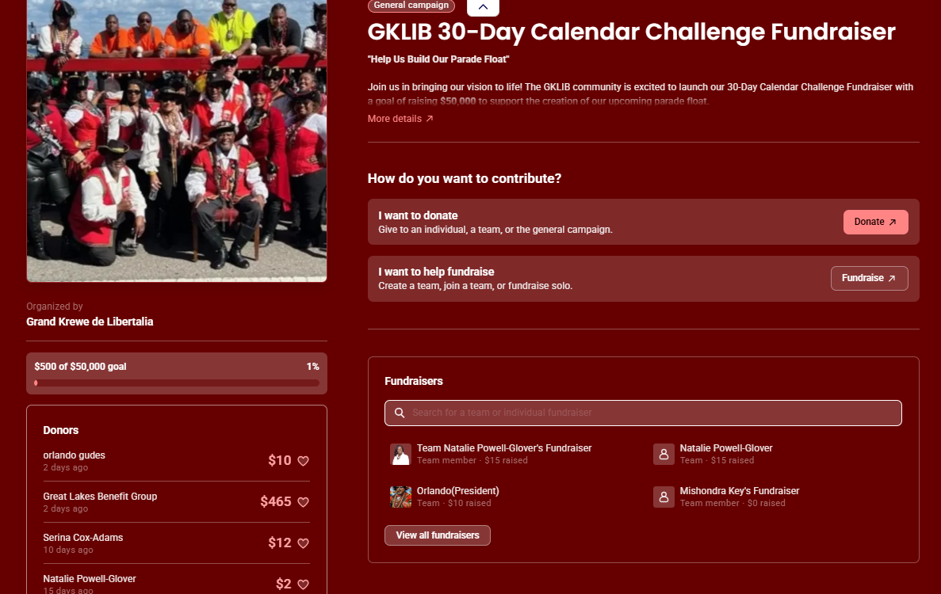

STEP 3: To create a team, enter your Team Name, set your Campaign Goal (recommended: $500), and upload a team photo (optional). Next, provide your Name and Email Address, then click Create Team to complete the setup process.
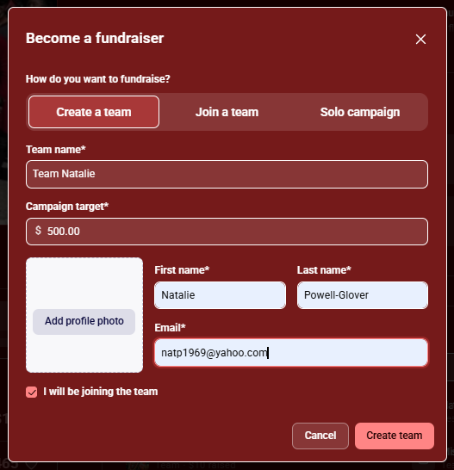

STEP 4: Once your campaign page is complete, you can begin sharing your fundraiser with family, friends, colleagues, and other supporters. Use the available sharing options to help spread the word, increase visibility, and maximize your fundraising efforts.
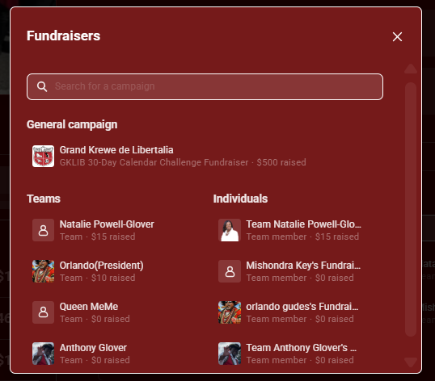
STEP 5: You should receive an email as shown below allowing you to share your campaign. Begin by viewing your campaign.
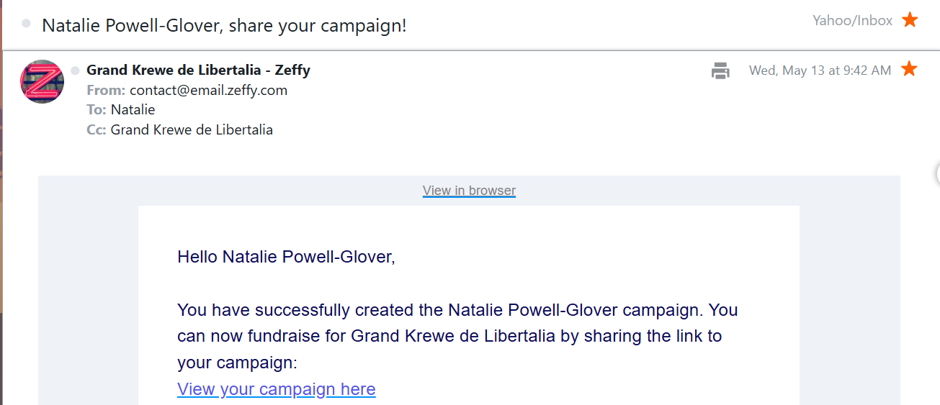

STEP 6: Click the Share Campaign button below to promote your fundraiser, encourage participation and support.
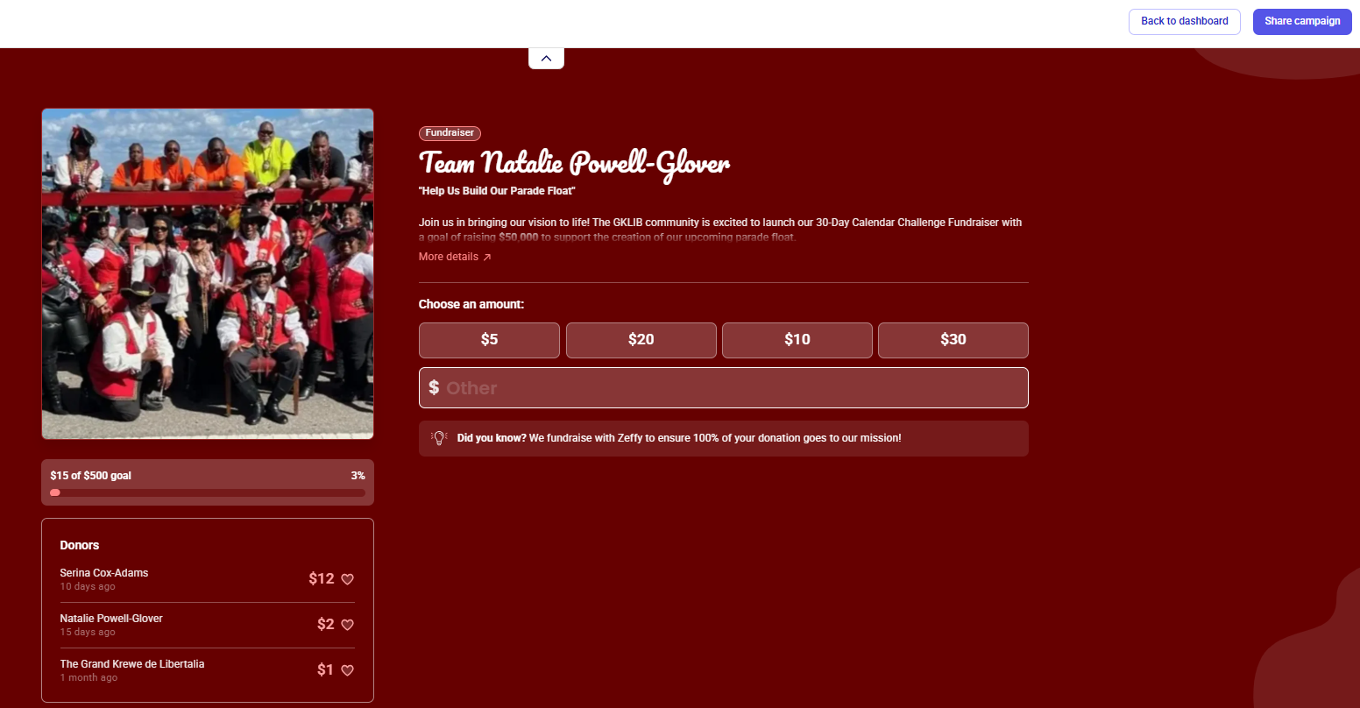

STEP 7: You can now copy the campaign link and share it with others to direct them to your fundraising page. You may also click the QR Code option below to generate a QR code that can be distributed via email, social media, flyers, or printed materials. Supporters can simply scan the QR code to access your campaign page directly.

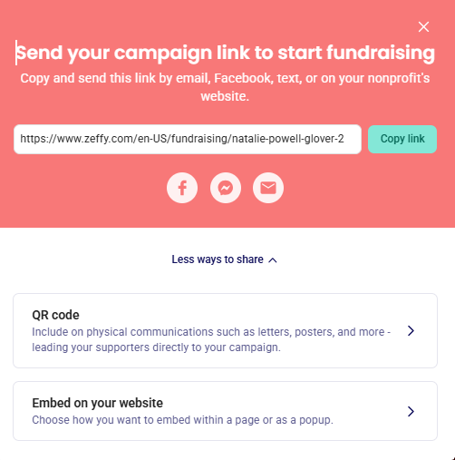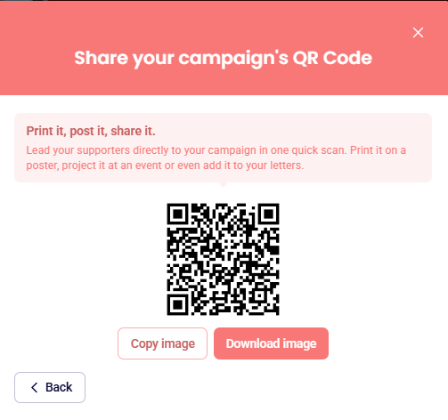
https://www.zeffy.com/en-US/fundraising/natalie-powell-glover-2

STEP 8: Your supporters can now proceed with making their payment based on the date selected on the calendar. If the displayed amount does not reflect the amount they wish to contribute, they may select the $Other option and enter their preferred donation amount. Once completed, click Continue to proceed with the payment process.
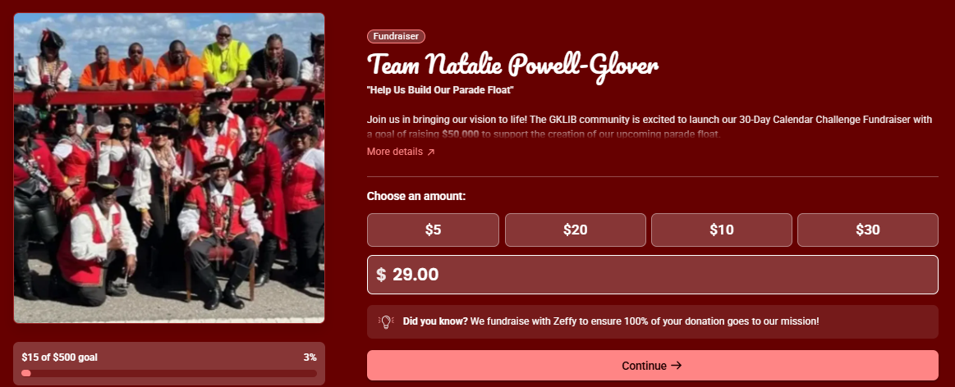
STEP 9: Verify that the donation amount selected is correct. Next, locate the section displaying a 17.00% contribution charge associated with the donation. Click the down arrow and select Other from the dropdown menu to customize the contribution amount.
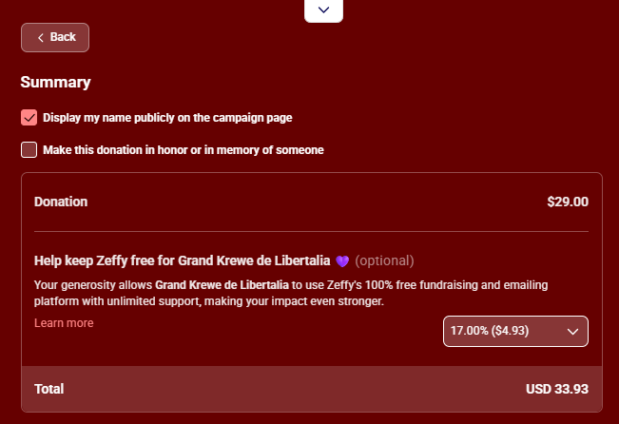
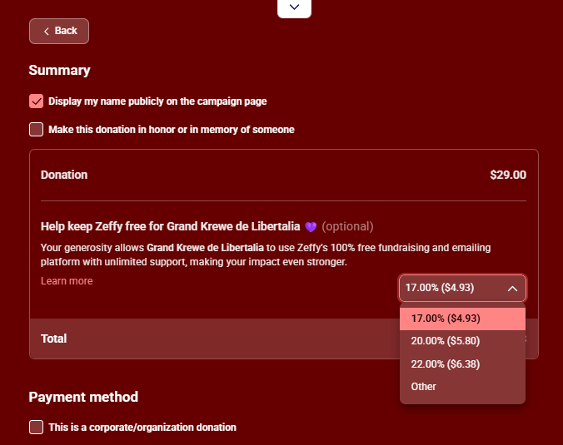

STEP 10: Supports can prepare to make a payment as shown below.
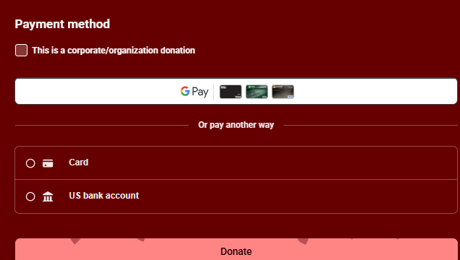

STEP 10: You can now move forward and begin campaigning. Don’t forget, the deadline is June 30th. Below is your personal tracking spreadsheet to assist with your campaign.

TRACKING SPREADSHEET
